User Guide
User Guide
Get organized. Stay creative.

Introduction
Milanote is a tool for organizing creative projects into visual boards. This guide walks you through the process of signing up, creating boards, adding content, and collaborating with others.

Step 1: Create an Account
Go to milanote.com and click 'Sign up for free'. Choose email, Google, or Apple to create an account.

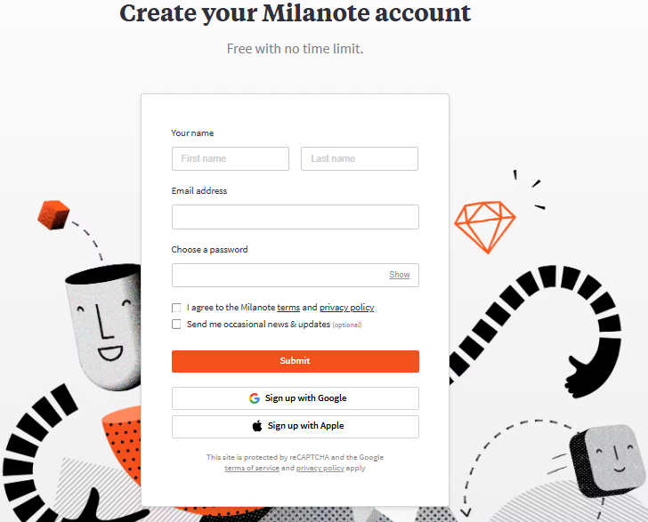

Step 2: Explore the Dashboard
After signing in, you’ll see the main dashboard with navigation sidebar, board list, and settings.

Step 3: Create Your First Board
Drag your 'New Board' and name it. You’ll enter a blank workspace ready for your ideas.

Step 4: Add Content
Use the '+' menu to add notes, images, and links. Drag them into place on your board.

Step 5: Organize Your Board
Group content into columns, apply colors, and arrange items for clarity.

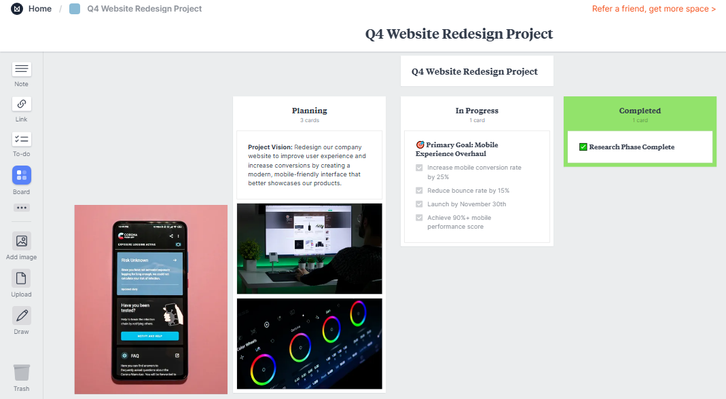

Step 6: Share and Collaborate
Click 'Share' in the top-right corner to invite team members with view or edit permissions.

Step 7: Export and Present
Export boards as PDF, Word, or Image. Use Presentation Mode to walk others through your ideas.

